Link Container and Link Component

This component mostly uses in footer section.

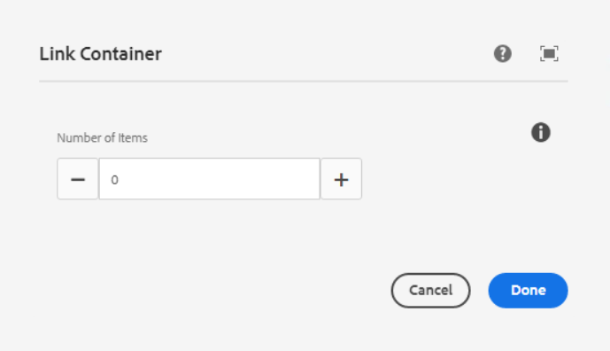

**Number of items** – Number of link components to add in the link container as per the below screenshot.

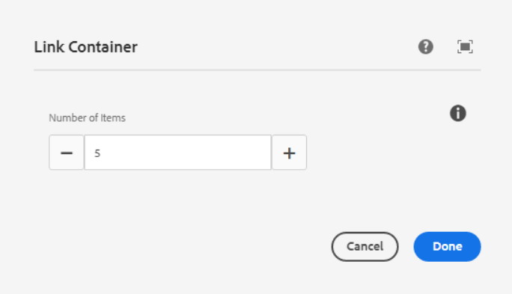

If we add 5 items, then 5 link components will be shown inside the link Container as per the below screenshot.

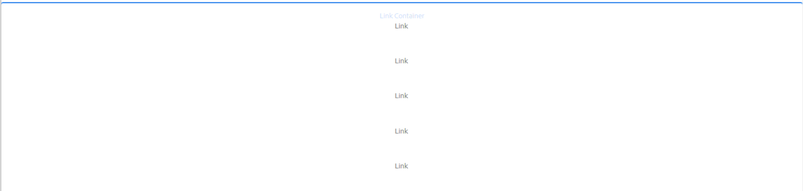

___________________________________________________________________

Link Component

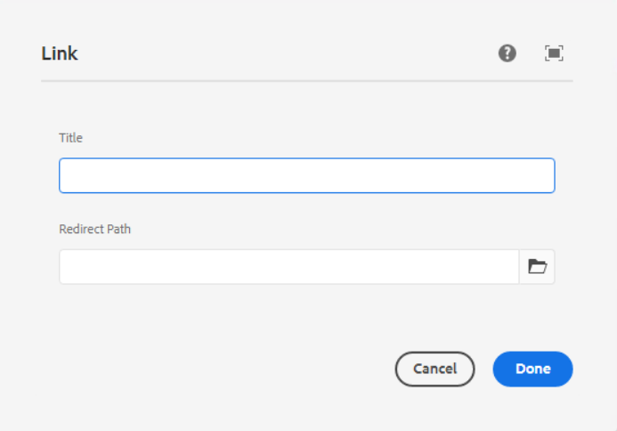

**Title** – This is for link title

**Redirect Path** – This is for the redirection path, we can give internal or external link here.

As per the below screenshot, we can add title and redirection path.

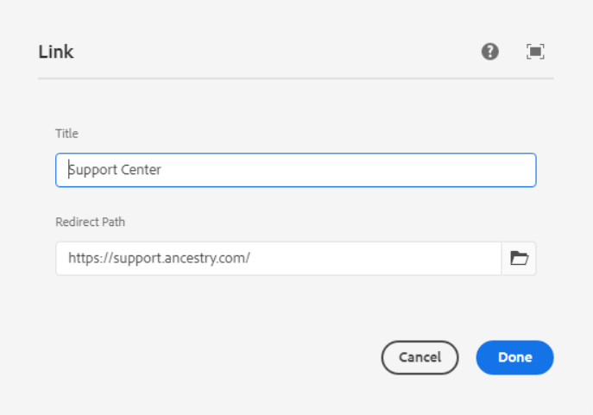

**Page Reference** - <https://www.ancestry.com/corporate/>

**AEM URL** - <https://author-ancestry-dev2.adobecqms.net/content/experience-fragments/ancestry-corp/us/en/site/footer/master.html?wcmmode=disabled>

